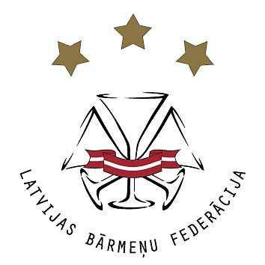
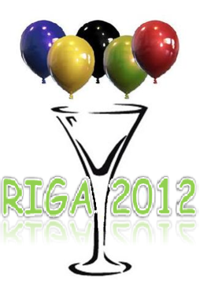
3rd annual
bartender summer games

Rules.

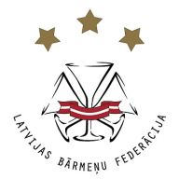
Organizers:

Latvian Bartenders Federation

Date and place:

4th of July @ 12.00
Mūkusalas street 73, Riga at

Sponsors and supporters of the games:
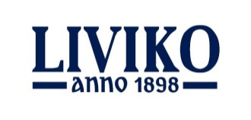
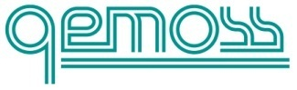

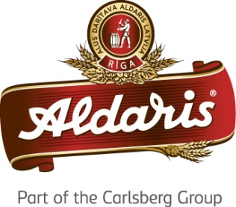
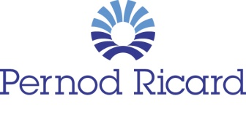
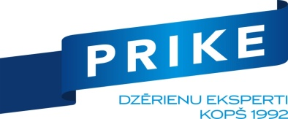

IT support:

Informative support:
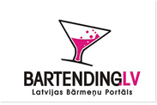

Objective:

This is a fun event where you can meet other bartenders and other proffessionaly related persons in a very nice and relaxed athmosphere. The goal of this event is to unite bartenders all over the world and have fun.
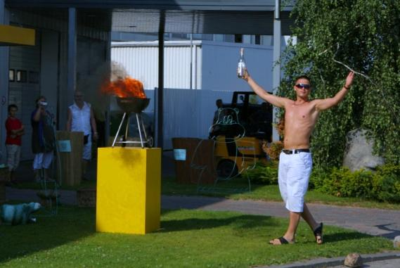
Participants:
This is a team event and each team have to consist from 3-6 people (Sex doesn’t matter), who are related to bartending industry. Each member of the team must be at least 18 years old.
Each team has to have a name.
It would great if each team had a flag and unite outfit since these are Olyimpic Games after all.

Registration
Entry form must be sent to welcome@bartender.lv until June 29th

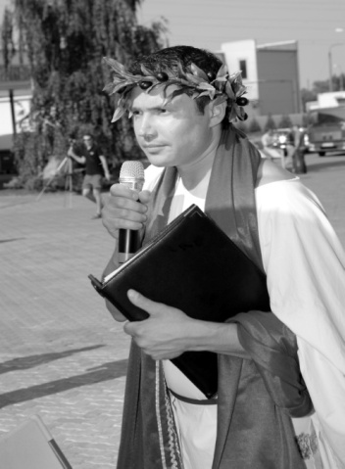
Dresscode:
Oiginal, sportive, free, creative and most important unite for the whole team.
P.S. There will be a special award for the most original dress code.

Rules:
Discipline:
- „Stock-taking” – the thing you do once a month in a bar...
- „Who’s got the longest one..?” – from something small, you will have to make something big and beautiful ;
- „Halfshift” – speed contest:
- This is a peed mix event for jsut one of the members of the team. Themain objcetive is to make a golden classic „Vodka Fizz” as fast as one can, respecting the recipe below:
    - Vodka Absolut 40 ml
    - Lemon juice 20 ml
    - Powder sugar 2 tejk.
    - Soda top up (Vichy glass bottle)
    - Method: shake & strain and top up
    - Glass: high-ball
    - Garnish: Lemon slice, cocktail cherry, straw.

- NB! In the process of making this coktail everybody MUST use a jigger to pour vodka and lemon juice (40/20 jigger), which will be provided for each competitor before this round. You can use your own other tools (shaker, scoop, thongs etc);
- There will be a starting signal given to everybody (Ready, steady GO!!!) and the time is stopped at the moment you raise your arm up high;
- Mistakes are not acceptable and therefore each single mistake will be penalized with 5 seconds added to time ( The penality can be bigger due to terrible mistakes and huge disrespect to the recipe);
- Organizers have the right to slightly change the rules of this discipline.

- „Who’s the hottest?” – speed ice melting;
- „Who’s the most precise” – highpouring;
- „Team relay” (objectives will be announced on the spot to keep it more interesting ).

Evaluation: Teams will get points for each of the disciplines. The points will be summed together and the team who will get the most points will be the winner of the games.
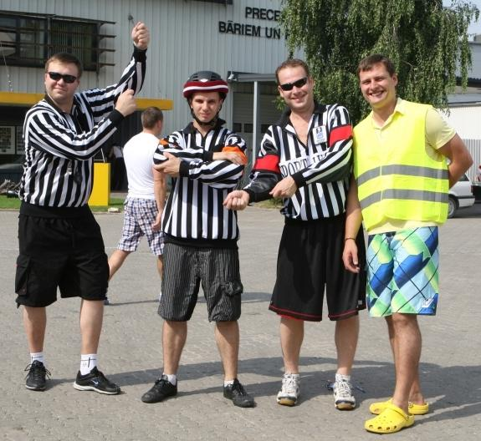
1st place – lots of points
2nd place - little less points
3rd place - even less points
4th place - very few points
5th – almost no points

Judges and Jury: LBF members, friends and supporters.

Main Discipline
„Who’s better? („mixing with a bartender” or „bartenders got talent”).

Time limit: 5 minutes..

Competition category: totally free style (in the process of making the cocktail it isn’t neccessary to use classic or flair techniques, main thing has to be show, doesn’t matter if it is dancing, singing, reading a poem, acting a scene or doing anything else that can be described as a good show).

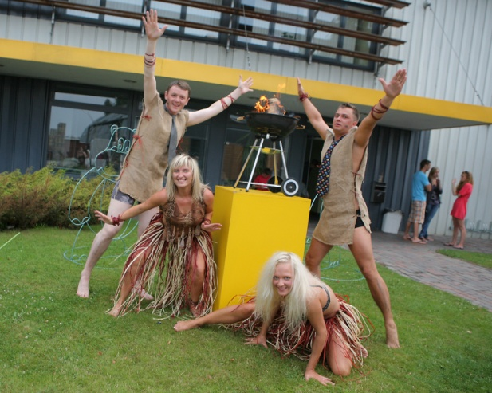
Music: If your performance needs a musical backgound, please burn an audio CD

Cocktail:
- The recipe has to be created by the members of the team. The recipe and the name of the cocktail must be original ;
- Cocktail category – any;
- Maximum ingredients - 6;
- 1 portion has to be made on the stage (volume, glassware, garnish will be judged by its originalty, so let your creativity fly );
- All alchoholic ingredients must be chosen from the list below (only those are allowed);
- Organizers will supply with all the drinks from this list.

LBF Partner | Drink | Brand
 | Rum | Bacardi Superior/ Gold/ Black/ 8 YO/ Lemon/ Razz/ Apple/
 | Vermouth | Martini Bianco/ Rosato/ Rosso/ Extra Dry/
 | Gin | Bombay Saphire
 | Sparkling wine | Martini Asti/ Rose/ Brut/ Prosseco/
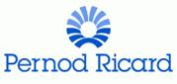 | Vodka | Absolut Vodka/ Raspberry/ Citron/ Peppar / Ruby Red/ Apeach/ Vanilia/ Mandarin/ Kurant/ Pear/ Berry Acai/
 | Whisky | Jameson, Jameson 12YO
 | Liquer | De Kuyper Amaretto/ Apricot Brandy/ Cherry Brandy/ Cranberry/ Creme de Bananes/ Creme de Cacao Brown/ Creme de Cacao White/ Creme de Cassis/ Curacao Blue/ Sour Apple/ Sour Rhubarb/ Triple Sec/Strawberry/Pisang/Cherry/  Bailey’s, Grand Marnier
 | Tequila | Jose Cuervo Silver/ Gold/
 | Liquer | Allažu ķimelis, Benediktīns
 | Balsam | Riga Black Balsam, Riga Black Balsam Blackcurrant
 | Cognac | Remy Martin V.S., Remy Martin V.S.O.P.
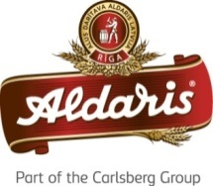 | Beer | Aldaris (all available products)
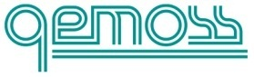 | Syrups & Purees | Monin (all available products)

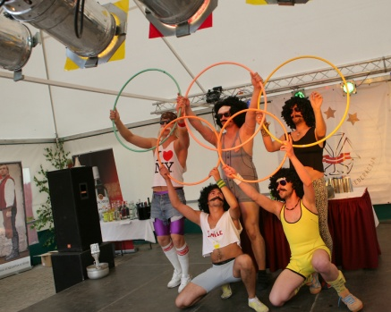
- Other NON-ALCHOHOLIC ingredients can be used but they are competitors responsibility and will not be supplied by organizers;
- All the neccessary tools and glassware for the cocktail preparation are competitors responsibility;
- Ice will be supplied!!

Judging crietria:
- There will be 3 judges who will evaluate each performance from close distance
- After each team jugdes will give their comments on what they did see on the stage (just like the talent shows) and give marks to each team, based on the criteria bellow:
  - appearence of team;
  - dresscode;
  - music;
  - story;
  - originality/creativity;
  - crowd interaction;
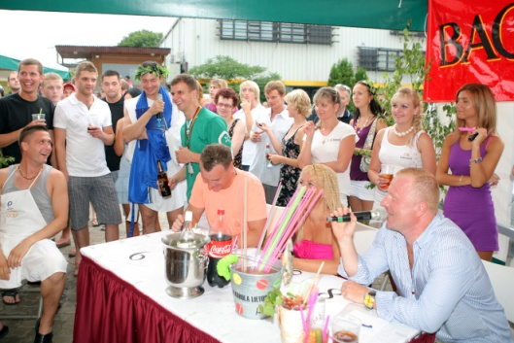
  - general impression;
- Judges will also give their opinion about the cocktail made during the show and will also give marks for the cocktail. Criteria:
  - apperance;
  - aroma;
  - taste;
  - originality
  - general impression.

Disqualifiation:
    - underaged member of the team;
    - not attending a discipline;
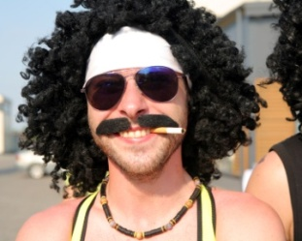
    - Falsification of results;
    - Giving incorrect information about the team;
    - Unethical behaviour and overconsuming alcohol (during the games all sportists must stay away from the booze and leave it for the afterparty).

Winners:
The team that gets the most points after all the disciplines will be awarded the Winners of the Bartenders Summer Games 2012

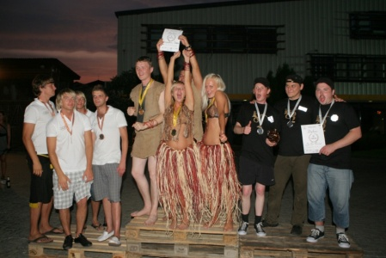

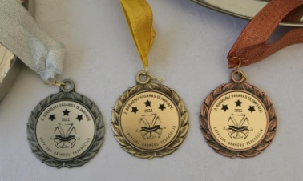
Awards:
- place – medals + trophy;
- place – medals
- place – medals

After the games it is time for celebration with live music and dances.

Photos from previous Games:
http://www.bartender.lv/?page=galleries&cid=11 – 2010
http://bartending.lv/foto/2-barmenu-vasaras-olimpiade – 2011

Video footage from last year’s event -
http://www.youtube.com/watch?v=vBcDIT_1GyU&feature=youtu.be

If there are any questions don’t hesitate to contact us ivars@bartender.lv, raitis@bartender.lv, or call (+371) 26 872 934 (Ivars) or (+371) 26 221 355 (Raitis).

